Lab 5: Ethernet and ARP

James Palmer

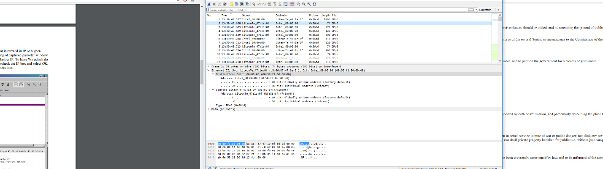

1. b8:86:87:47:1e:0f
2. 00:50:f1:80:00:00
3. 0X86dd which means this this frame is of the IP Protocol type.
4. Looks like 74 bytes from the start

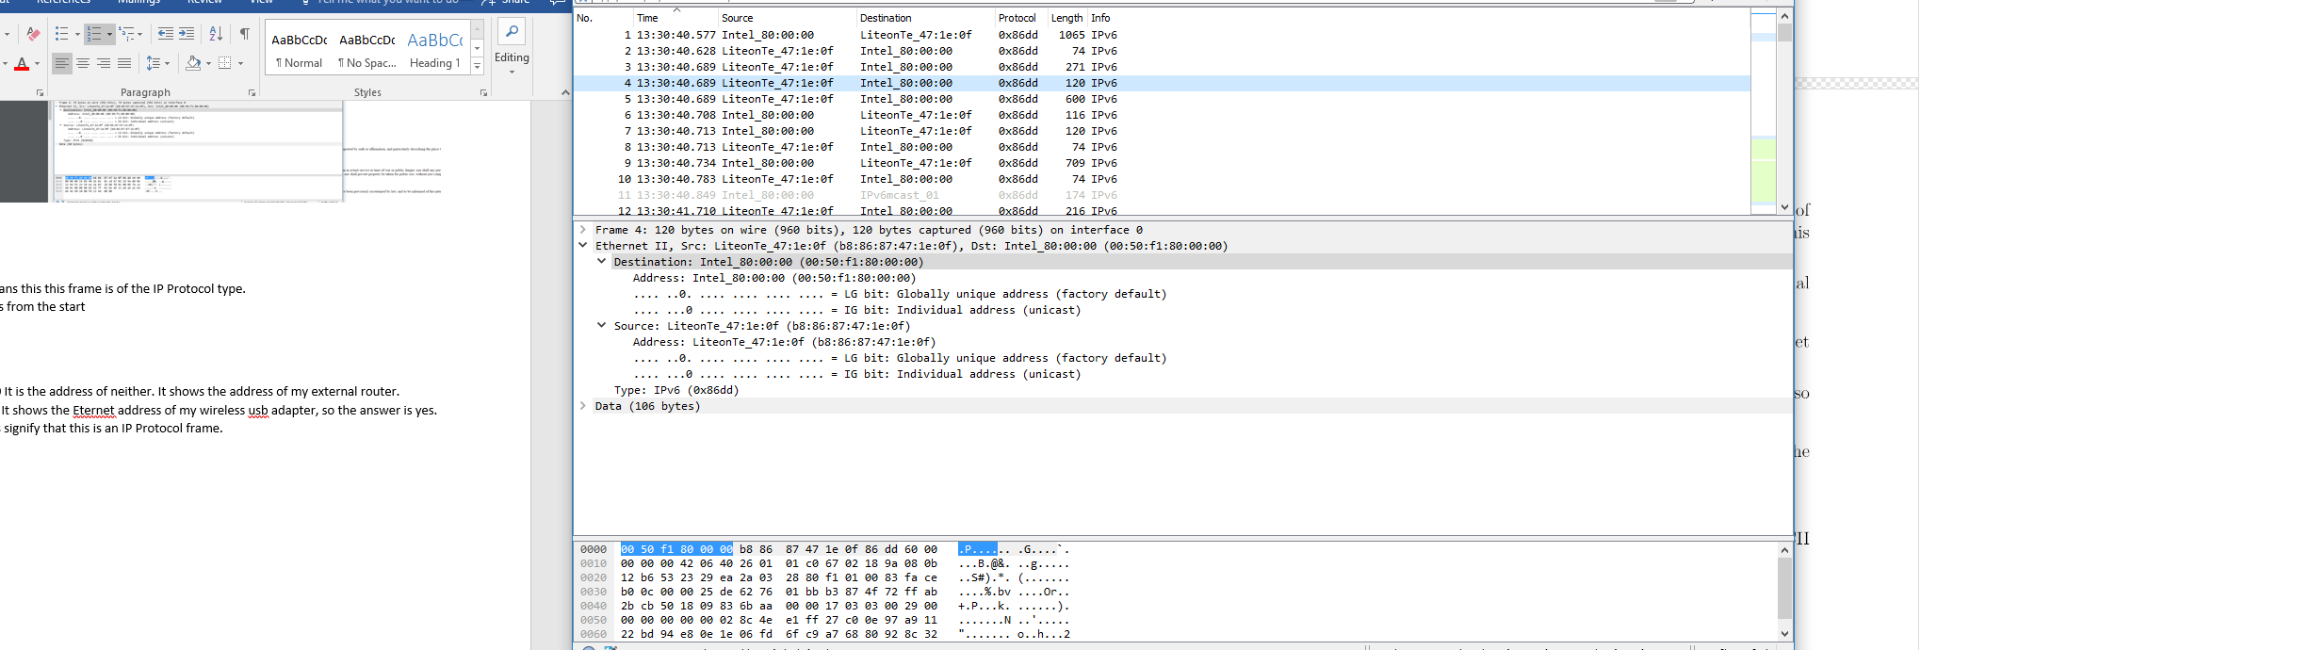

1. 00:50:f1:80:00:00 It is the address of neither. It shows the address of my external router.
2. b8:86:87:47:1e:0f It shows the Eternet address of my wireless usb adapter, so the answer is yes.
3. 0X86dd These bits signify that this is an IP Protocol frame.
4. Looks like 120 bytes from the start/captured

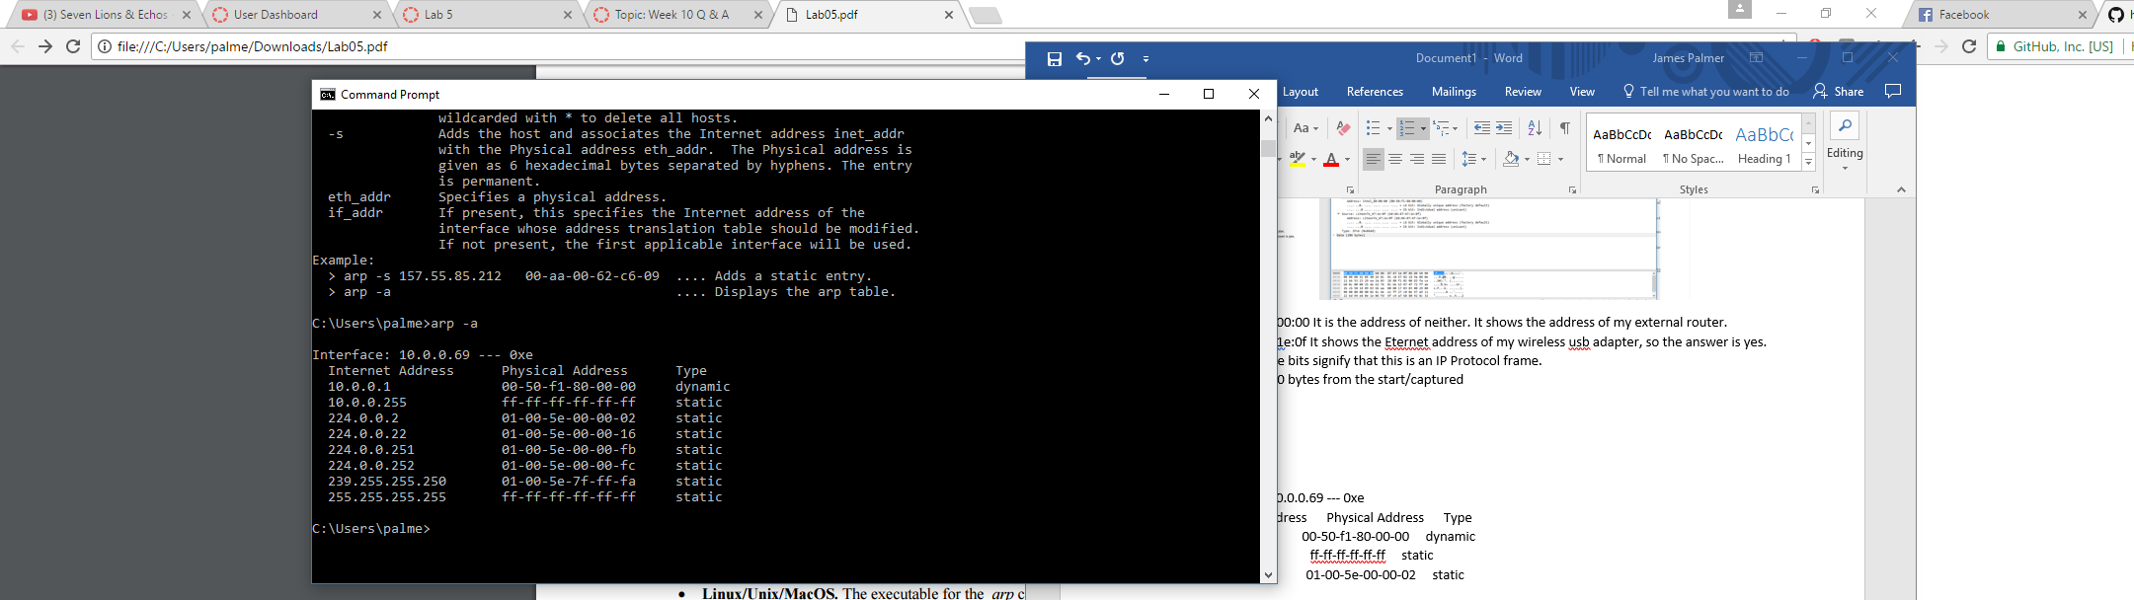

1. Interface: 10.0.0.69 --- 0xe

Internet Address Physical Address Type

10.0.0.1 00-50-f1-80-00-00 dynamic

10.0.0.255 ff-ff-ff-ff-ff-ff static

224.0.0.2 01-00-5e-00-00-02 static

224.0.0.22 01-00-5e-00-00-16 static

224.0.0.251 01-00-5e-00-00-fb static

224.0.0.252 01-00-5e-00-00-fc static

239.255.255.250 01-00-5e-7f-ff-fa static

255.255.255.255 ff-ff-ff-ff-ff-ff static

1. Source: b8:86:87:47:1e:0f Destination: ff:ff:ff:ff:ff:ff
2. 0x8000. It specifies that this packet is using the ARP protocol.

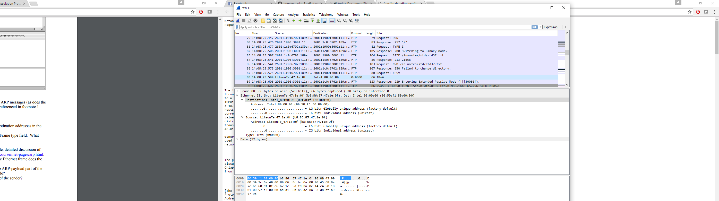

* 1. 21 bytes from the beginning
  2. 0x0001 (Request)
  3. Yes, it contains my IP address of 10.0.0.69
  4. Starting at 33 bytes and goes until byte 39. It comes just aver the sender Ethernet address and IP address is listed.

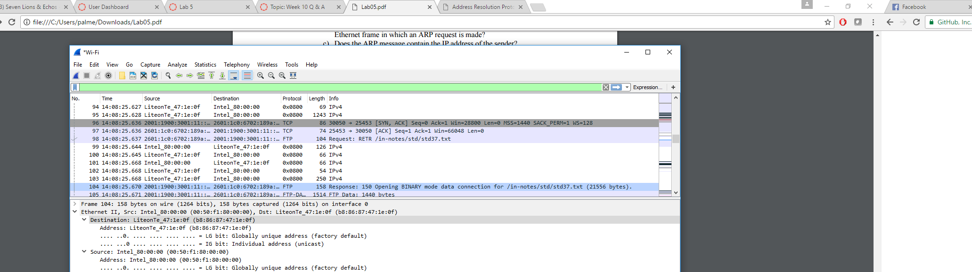

* 1. 150 Bytes
  2. 0x0002 (Request)
  3. 7 Bytes after the opcode. The 6 bytes after the opcode is used for the Ethernet address of the queried machine (taken from textbook).

1. Source: 00:50:f1:80:00:00 Destination: b8:86:87:47:1e:0f
2. I believe there is no ARP reply sent because the current Ethernet address in the request does not match my local machines hardware address.

**EXTRA CREDIT:**

1. This would disable the called interface. All outbound requests go nowhere.
2. 60 seconds is the default time. You can find this by typing in the command prompt in: /proc/sys/net/ipv4/neigh/wlan0/gc_stale_time